**Campus Navigator :Report2**

Experience of the User

Because of the interface's simple chat platform design, users can ask questions like "How do I get to the Admin Block?" or "Tell me how to get from the hostel to the library the quickest."

Module for Core Data

This page contains all of the important campus information, such as building locations, distances between buildings, frequently asked questions, and staff contacts. When a user requests information, the assistant retrieves pertinent data from this database, which serves as a knowledge base.

Layer of Language Understanding

Understanding user input is the responsibility of a specialized NLP component. In order to ensure proper handling, it differentiates between inquiries pertaining to general information (often requested questions) and navigation (finding a route).

Engine for Calculating Routes

This section identifies the source and the destination when a navigation-related request is submitted. To choose the best course of action, it then uses search algorithms including A* (A-star), Uniform Cost Search (UCS), Depth-First Search (DFS), and Breadth-First Search (BFS). The length of the route and the expected time to walk it are both included in the results.

Methodology

Campus as a Graph

Points of interest, such as the Main Gate, Administration Building, Engineering Block, Hostel, etc., are represented by nodes.

Direct routes between locations are indicated by edges.

Each path's length in meters is described by weights.

Techniques for Path Searches

Various algorithms are used, depending on the situation:

All potential routes are covered by BFS and DFS.

A* and UCS effectively determine the shortest route between two locations.

Recognition of Intent

Advanced natural language processing (NLP) technology deciphers questions and differentiates between requests.

The Campus Data collected till Date which will be used for navigation and all the location finding purpose is below

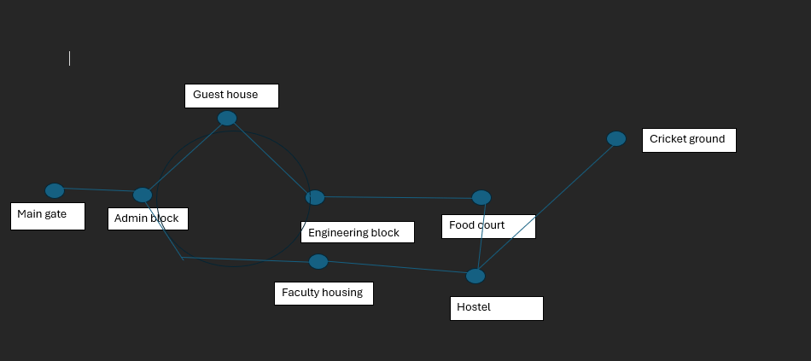

|  |  |  |  |  |  |  |  |  |
| --- | --- | --- | --- | --- | --- | --- | --- | --- |
| **From \ To** | **Main gate** | **Admin block** | **Engineering block** | **Guest house** | **Faculty housing** | **Food court** | **Hostel** | **Cricket ground** |
| **Main gate** | 0 | 260 meter | 400 metre | 410 metre | 590 metre | 630 metre | 820 metre | 1290 metre |
| **Admin block** | 260 metre | 0 | 140 meter | 200 meter | 430 metre | 400 metre | 600 metre | 1000 metre |
| **Engineering block** | 410 metre | 150 metre | 0 | 200 meter | 180 metre | 220 metre | 490 metre | 860 metre |
| **Guest house** | 410 metre | 200 metre | 200 metre | 0 | 360 metre | 395 metre | 660 metre | 1110 metre |
| **Faculty housing** | 590 metre | 430 metre | 180 meter | 370 metre | 0 | 265 metre | 250 metre | 690 metre |

|  |  |  |  |  |  |  |  |  |
| --- | --- | --- | --- | --- | --- | --- | --- | --- |
| **Food court** | 630 metre | 400 metre | 220 metre | 395 metre | 265 metre | 0 | 250 metre | 640 metre |
| **Hostel** | 820 metre | 600 metre | 490 metre | 680 metre | 210 metre | 250 metre | 0 | 500 metre |
| **Cricket ground** | 13200 metre | 1000 metre | 890 metre | 1000 metre | 690 metre | 650 metre | 500 metre | 0 |